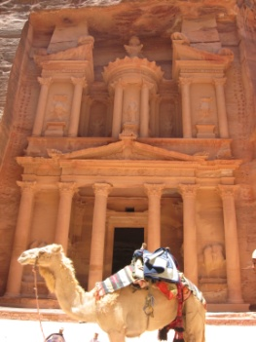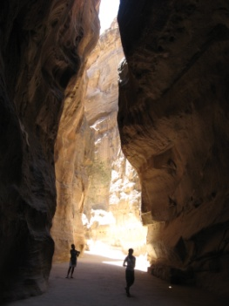

‘EXPERIENCE’ THE HOLY LAND
JORDAN PRE-TRIP OPTION
27 JULY – 31 JULY 2021

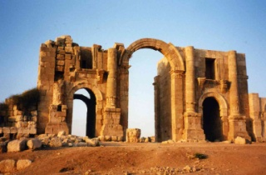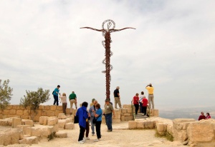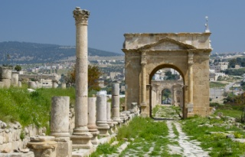
DAY TO DAY ITINERARY

TUE. 27 JULY: Departure for Jordan
Tonight, we depart from Toronto on our overnight flights to Amman. Group seating will be pre-assigned by the airline for our flight. Dinner and complimentary in-flight service will be provided this evening. (D)

WED. 28 JULY: Arrival in Jordan
This afternoon, we arrive in Amman. Welcome to Jordan! Here, we are met and given assistance with clearing customs and baggage formalities before our journey begins. Our overnight stay will be in the ancient city of Amman for tonight.

THU. 29 JULY: Jerash, Mt Nebo, Madaba
After breakfast, we leave the hotel. Our journey to Petra includes visits to:
Jerash – Overshadowed by Petra, the ancient City of Jerash is acknowledged internationally as one of the largest and best preserved sites of Roman architecture outside of Italy. Here, we shall have lunch before continuing on our journey.
Mt. Nebo – From here, we can see across into the Promised Land just as Moses did before being laid to rest. On a clear day, we can see the hills of Jerusalem with Jericho in the foreground.
Dinner and overnight stay will be at Petra. (B, D)

FRI. 30 JULY: Petra
After breakfast, we begin our visit of Petra. Petra was chosen as the capital of the Nabateans because it was located in a valley surrounded by sandstone mountains.
The main entrance to Petra is called the Siq with sides as high as 200m. It was here that Christians escaped from the siege of Jerusalem by Titus in the 1st century. This gorge and the temple at the end of it (the Kazneh) were popularized in American culture in the movie, Indiana Jones and The Last Crusade.
The Kazneh – Of the 800 carved tombs in Petra, the Kazneh is the most famous. Its name Kazneh means ‘treasure’ and comes from the Bedouin belief that the Pharaoh chasing the Israelites hid his treasures in the urn at the top of the Kazneh.
Dinner and overnight stay will be at our hotel in Aquaba, located by the Gulf shores. (B, D)

SAT. 31 JULY: Gulf of Aquaba and Crossing into Israel
This morning, we have free time by the Gulf of Aquaba, then a short drive to the Israeli border crossing.
Once through customs formalities, we enter Israel, meet our guide and driver who will take us to our hotel by the shores of the Dead Sea. Here, we will join our fellow travelers who arrived today. (B,D)

IF 10 PAID PASSENGERS: USD$745 so approx. CAD$1050
IF 15 PAID PASSENGERS: USD$685 so approx. CAD$969
IF 20 PAID PASSENGERS: USD$655 so approx. CAD$925

INCLUDED

- Hotels: First class hotels throughout.
- Meals: Full breakfast and dinner daily (some hotels charge for tea and coffee at dinner.)
- Transportation: Air conditioned luxury coach service throughout the tour.
- Sightseeing: Comprehensive program as per itinerary, including all entrance fees.
- Tour Guide: Government licensed Tour guide will accompany the group and work with the Leadership Teams to maximize the educational/spiritual benefits and enjoyment of the group.
- Porterage: One large suitcase per person. Each person is responsible for his/her other luggage.
- Jordan entry visa

NOT INCLUDED
- Lunches (unless mentioned in the itinerary)
- Gratuities: Equivalent to USD$45

GENERAL INFORMATION
Passport: Tour participants must be in possession of a valid passport which does not expire before 10 Feb 2022. USA and Canadian passport holders do not require a visa for Israel. Christian Journeys looks after the visa for Jordan.
Travel Insurance: Your Comprehensive Travel Policy includes ‘trip cancellation’ coverage to protect you against the cancellation penalties. Conditions apply so please ask for more details.
General Health: All tour members should be in sufficient good health to enjoy the tour in its entirety. Christian Journeys reserves the right to refuse participation in certain instances.

CHRISTIAN JOURNEYS

